**Project Proposal**

**NoiseSentinel:** Portable IoT Stick for Detecting Modified Bike Silencers

**By**

**Muhammad Moiz - 221073 Ifsan Imran - 221089 Mishkat Fatima - 221336**

***Supervisor***

**Dr. Abdul Hameed**



Department of Computer Science Air University Islamabad (AU)

Table of Contents

1. Introduction 3
2. Problem Statement 3
3. Problem Solution / Objectives of the Proposed System 3
   1. Proposed Solution Architecture 4
   2. Objectives 4
4. Related System Analysis / Literature Review 5
5. Scope 5
6. Modules 6

IoT Stick 6

Web Portal 6

Mobile App 6

1. System Limitations/Constraints 6
2. Data Gathering Approach 7
3. Tools and Technologies 7
4. Project Stakeholders and Roles 8
5. Module based Work Division 8
6. Gantt Chart 9
7. Mockups 9

# Introduction

Motorcycles with illegally modified silencers, often called “Phatphati bikes,” make very loud and disturbing noises that add to noise pollution in cities. This noise affects people’s daily lives and can even harm their health. Right now, it’s hard for traffic police to take action because they rely on old methods like listening and guessing, which are not always accurate. To deal with this problem properly, there is a need for a modern and reliable system that can detect these bikes and provide solid proof that works in court.

# Problem Statement

Right now, traffic police do not have a proper system to detect if a motorcycle’s silencer is illegally changed. They mostly rely on listening and their own judgment, which can be wrong. Also, when the police issue a challan (fine) for a noisy bike, it can be rejected in court when challenged because there is no clear proof like recorded sound. Courts often ask for the police officer’s testimony (shahadat), and if that is missing or unclear, the case can fail. This makes it hard to stop noisy motorcycles and control noise pollution in the city.

# Problem Solution / Objectives of the Proposed System

Our solution is a small, easy to carry IoT device for traffic police. This device listens to the motorcycle’s exhaust sound and checks if the silencer is illegally modified. It connects to a mobile app that records the temper-proof evidence like sound and the officer’s identity. If the device detects a problem, the app creates a digital challan (fine) with all this proof. All the information is saved. There is also a web portal where courts and authorities can see this proof online, so the officer does not have to come to court in person. This system will help make sure noisy motorcycles are caught and fined properly, reducing noise pollution and making cities quieter.

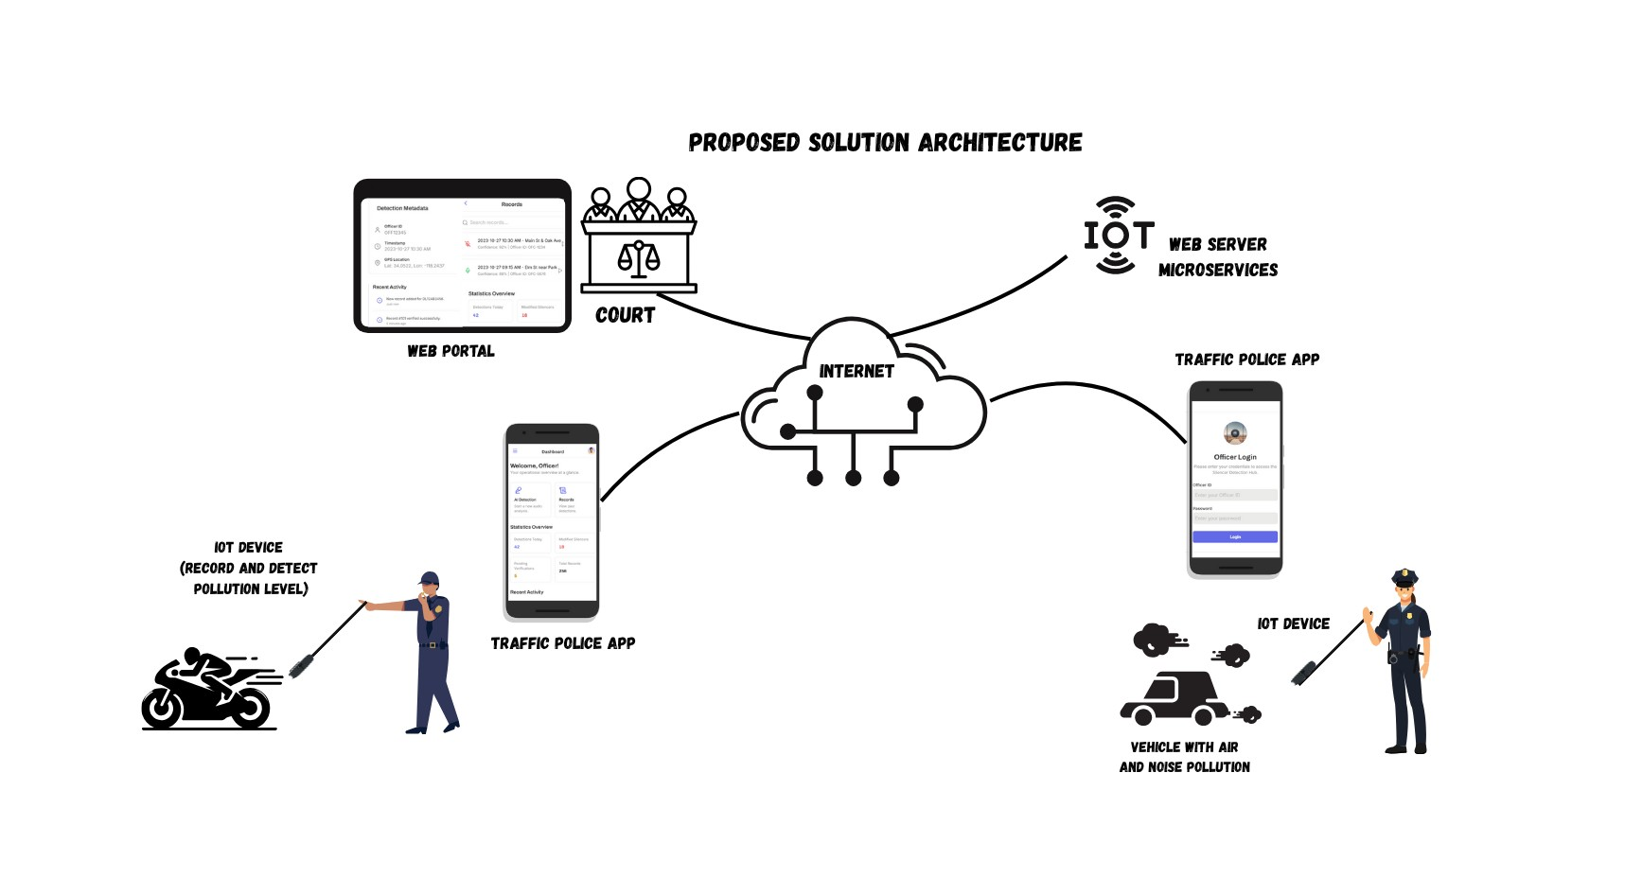

## 3.2 Objectives

The main goals of our proposed system are:

* To help traffic police easily detect illegally modified motorcycle silencers using a smart IoT device.
* To provide tamper proof evidence including sound recordings along with officer identity.
* To generate digital challans through a connected mobile app when a violation is detected.
* To allow courts and authorities to view evidence remotely, without needing the officer’s testimony or bike in court.
* To make it easier for relevant departments to monitor the progress of each case.
* To improve the legal process with reliable, technology based proof that is acceptable in court.

|  |  |  |  |  |  |
| --- | --- | --- | --- | --- | --- |
| **Existing Solution** | **Key Limitations** | **Audio Detection** | **Evidence Recording** | **Web Portal Access** | **Our Proposed IoT System** |
| **Manual Bike Checks by Traffic Police** | Based on human hearing. | ✘ | ✘ | ✘ | * Audio-based ML powered silencer detection with legal evidence. |
| **UK Noise Camera Trials** | Fixed location cameras. focused on cars only. | * (cars only) | * (limited) | ✘ | * Portable IoT device with mobile/web integration. |
| **Karachi safe city project with live vehicle, facial recognition.** | Focuses on signal violations and speeding. no feature for noise detection or silencer modifications | ✘ | ✘ | ✓ (limited traffic data) | * Silencer specific detection audio evidence and officer free court validation |

# Scope

This system is designed for traffic police in busy urban areas to detect illegally modified motorcycle silencers using a small handheld IoT device and mobile app. It records tamper-proof evidence, then generates a digital challan and stores all data. Courts and authorities can view the evidence and case status, so officers or bikes don’t need to appear in person. This solution focuses on silencer checks and digital challans, helping reduce noise pollution and ensuring reliable, court-ready proof.

# Modules

* + **IoT Stick**
    - **App Connectivity:** Pair with the mobile app via Bluetooth/WiFi.
    - **Noise/Sound Classification:** Analyze exhaust sound to detect modified silencers.
    - **Pollution Classification:** Determine if the noise level exceeds legal limits.
    - **Data Forwarding:** Send recorded audio, timestamp, and officer ID to the mobile app.
  + **Web Portal**
    - **Login / Signup:** Secure access for officers, courts, and administrators.
    - **Officer / Court Registration:** Create accounts and manage user roles.
    - **Report Generation:** Generate detailed reports of challans and evidence.
    - **Record Search:** Search past cases by bike registration, location, date, or officer.
    - **Challan Updates:** View and update the status of each digital challan.
  + **Mobile App**
    - **Notification & Dashboard:** Receive alerts when a modified silencer is detected. view summary of issued challans.
    - **Challan Generation:** create a digital challan with audio evidence, and officer ID.
    - **Pairing IoT Device:** Connect to the IoT Stick to capture and classify exhaust sound.
    - **Record Search:** Look up existing challans or evidence records on the go.

Search past cases by bike registration.

* + - **Login / Signup:** Secure officer authentication and profile management.

# System Limitations/Constraints

This system only focuses on detecting illegally modified motorcycle silencers and generating digital challans. It does not handle other vehicle violations like over speeding etc. The handheld device is a prototype and it is paired to a mobile app and needs an

internet to upload data, so it may not work well in areas with poor coverage. Additionally, there is no integration with national or third-party traffic databases at this stage (though such integration could be added in the future).

# Data Gathering Approach

We will collect audio samples of motorcycle exhausts to train a model that distinguishes between legal and illegal silencers. First, we will record sounds from a selection of motorcycles known to have standard silencers and those confirmed to be modified. Each recording has a unique identifier for reference. These labeled samples will form our initial “legal” and “illegal” dataset. Over time, we will add more recordings captured under different conditions to strengthen the dataset. Feedback from field tests and our supervisor will guide dataset improvements.

# Tools and Technologies

|  |  |  |
| --- | --- | --- |
| **Tool / Component** | **Technology / Framework** | **Purpose / Rationale** |
| **IoT Device** |  | Captures motorcycle exhaust sound. |
| **Mobile App** | **React Native** | Connects to the IoT device, runs the ML model to detect illegal silencers, and generates digital challans. |
| **Web App** | **React** | Provides a portal for courts and authorities to view evidence. |
| **ML Model** | **Classification Decision Tree** | To classify silencers as legal or illegal. |
| **Database** | **SQL** | Securely stores all data. |
| **Backend / API** | **Node.js / Express** | Manages data flow. |
| **Version Control** | **Git** | collaboration. |

# Project Stakeholders and Roles

**Project Sponsor**

Air University Islamabad

**Stakeholder** ● Dr. Abdul Hameed (Supervisor)

* Muhammad Moiz
* Ifsan Imran
* Mishkat Fatima
* Final Year Project Committee: Evaluation of project

# Module based Work Division

|  |  |  |
| --- | --- | --- |
| **Student Name** | **Student Registration Number** | **Responsibility/ Module / Feature** |
| Muhammad Moiz | 221073 | IoT Work |
| Ifsan Imran | 221089 | Mobile App |
| Mishkat Fatima | 221336 | Web Portal |

# Gantt Chart

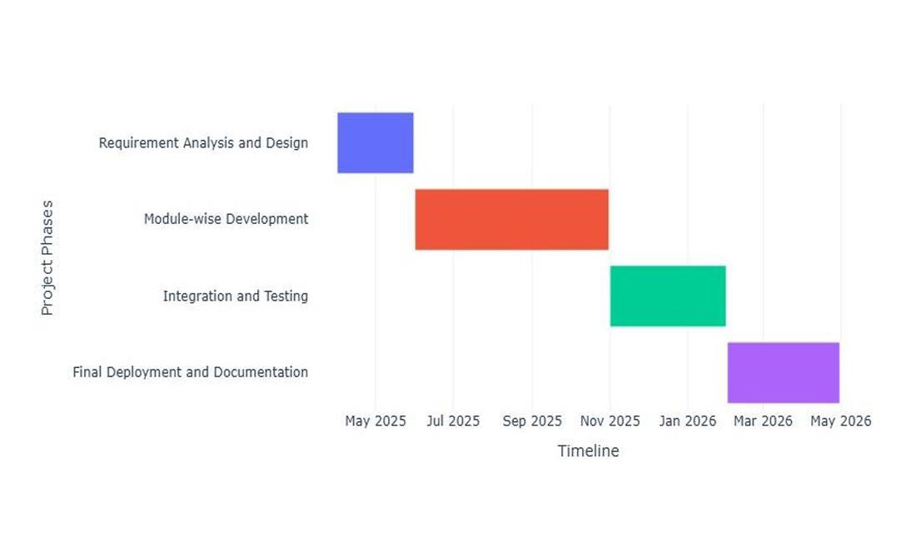

# Mockups

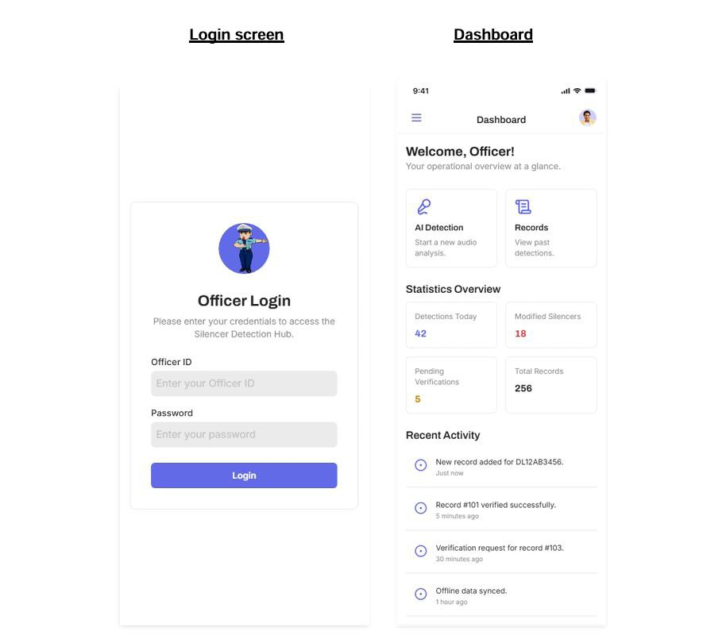

Record

AI Detection

< Records

Q



..•JJ? -

9:41

AI Detection

2023•10--2710:30 AM • M3in St & 031c: Ave [>

Conf" .92 Off!Cet II); OfC·1234

2023·10·27 09:15AM·Elm Stnear Park [> C

Cont rSenu 88 Oftle:ef 10 Of-C·S018

2023·10·26 04:oo PM •Hjghway 101Ex t s [::>

COflrodef'lcf> 95% 1OffiC• .,..OFC-1234

2023·10·26 03:30PM ·Downtown Square [>

Coni 85";;. OffiCer 10 OFC-9012

2023·10·26 02:00PM· RMidOntl.alAtea A [>

COnfodo 78'1o': IOrf<etiO-OFC-5878

2023-10 25 11:00 AM - IndustrialPark [> G

C fod!MU: 90'X IOffiCe< 10:()(C-9012

Audio Recording



Audio Waveform

lc!le

2023-10-25 10:30 AM *Neat* hOOI Zona t>

Corrf 8:i''!le OtfJC lO OfC·1134

(W Veform Visualization Area I